|  |
| --- |
| Functional Specification – LSMW Long Texts Upload using DI |

|  |  |
| --- | --- |
| **1. Project:** | |
| **2. FS Name:** Long Texts upload LSMW using Direct Input Method | |
| **3. Reference: NA** | **4. Business Process:** |
| **5. SAP Module:** All | **6. Business Sub Process:** LSMW-DI |
| **7. Author:** | **8. Reviewed By:** |
| **9. Status:** <Created/  Reviewed/Approved/Descoped> | **10. Status Date:** |
| **11. Priority:** <High/ Medium /Low> | **13. Process Owner :** Upender Reddy N |
| **12. Version No: 1.0** |  |

13. Document Revision History:

|  |  |  |  |  |
| --- | --- | --- | --- | --- |
| **Rev. No.** | **Change Request No.** | **Affected Pages** | Description of Change | **Date of Revision** |
|  |  |  |  |  |
|  |  |  |  |  |
|  |  |  |  |  |
|  |  |  |  |  |
|  |  |  |  |  |
|  |  |  |  |  |

14. Definition:

|  |  |
| --- | --- |
| **Migration Title:** | LSMW Long Text Upload |
| **Associated Business Event:** |  |
| **Application:** | NA |
| **Comments:** |  |

15. Purpose:

Purpose of this LSMW object is to develop common data load utility for any long texts in R/3 across all modules.

This object will use LSMW standard object with direct input method.

16. Assumptions:

2 Text Files will be provided by business client.

1. Header File (Will Contain Header Details of Long Text object)
2. Line Item File (Will Contain Texts for Long text object) – This is required because SAP upload long text by breaking long text into 72 char long string.

Example – Suppose here we want to upload purchase order long text of length 144 char than we have to break this long text into 2 lines of 72 char each for that particular object.

Files will be tab delimited text files and file contains column headers.

17. Interface - Business Process Description:

Not Applicable

18. Conversion Type:

LSMW – DI-Ditect Input

19. Periodicity:

As & when required

20. Process Flow Diagram:

NA

21. Processing Logic:

1. Create Project: <zproj>

2. Create Sub Project: <zsubproj>

3. Create Object: <zobj>

4. Assign / Choose Object Type and Input Method

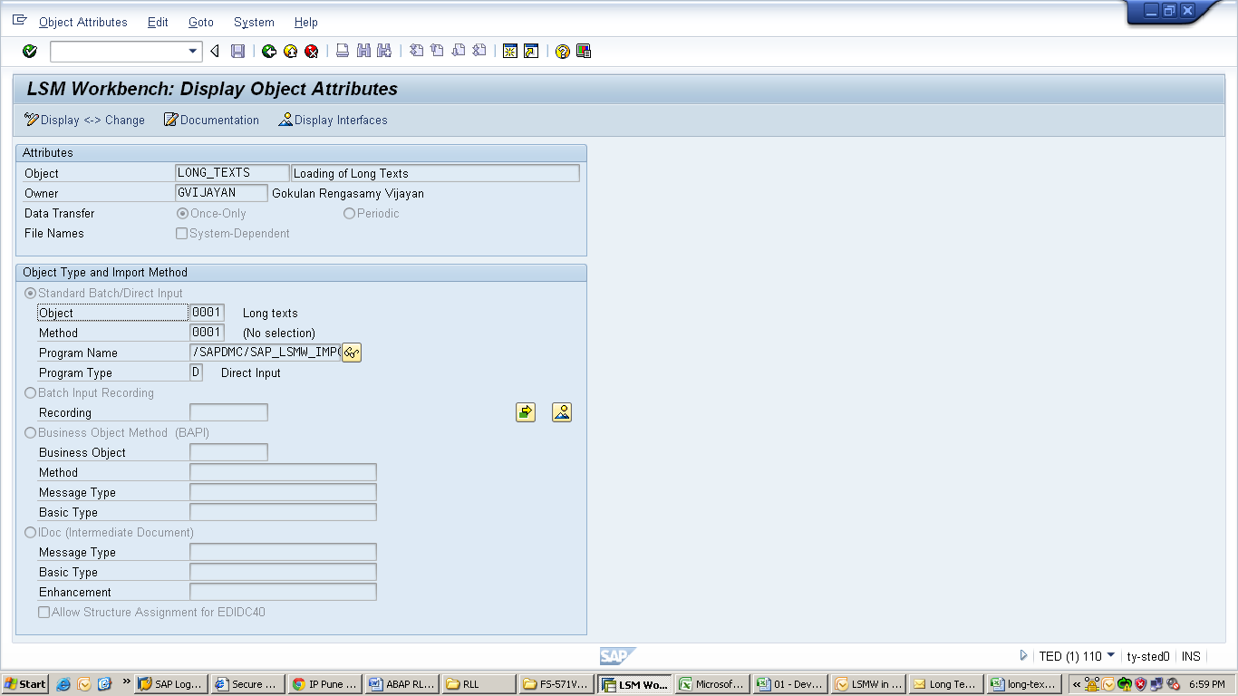

5. Maintain Source structures

* For Header – ZHEADER
* For Item – ZITEM (Under Header)

6. Maintain Source Fields for each source Structure

Header

|  |  |  |  |
| --- | --- | --- | --- |
| **OBJECT** | **NAME** | **TXTID** | **SPRAS** |

Item

|  |  |  |
| --- | --- | --- |
| **NAME** | **TEXTFORMAT** | **TEXTLINE** |

7. Maintain Source Structure Relations

8. Maintain Field Mappings

9. Specify Files – Files will be tab delimited Text file.

Both the files will be uploaded from Desktop.

22. Output Text View:

Long Text can be checked in T-code MK03🡪 Open uploaded vendor in display mode and in the second screen go to Extras then select text option. Long text will display in the popup display.

23. Selection Screen:

NA

24. File (Input/Output) Format:

|  |  |  |  |  |  |  |  |
| --- | --- | --- | --- | --- | --- | --- | --- |
| Sr. No. | Field Name | Field Type | Field Length | Format | Mandatory | Validations/Comments | Field Mappings |
|  |  |  |  |  |  |  |  |

Input – Source from the desktop.



**25. Field Mappings:**

**Table Definitions**

|  |  |  |  |  |
| --- | --- | --- | --- | --- |
| **Sr. No.** | Field name | **Data Type** | Length | **Primary Key/Remarks** |
|  |  |  |  |  |

26. Participating Systems:

**From System:\***

**NA**

**To System:\***

NA

**31. Sign-Off**

|  |
| --- |
| Signed-Off By: |
| Sign-Off Date: |